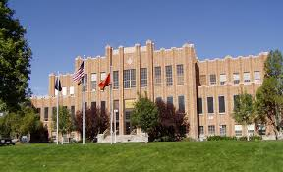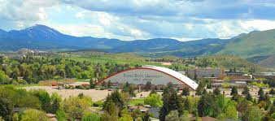
Northwest Center for Fluency Disorders
The Northwest Center for Fluency Disorders (NWCFD) Interprofessional Intensive Stuttering Clinic (NWCFD-IISC) is a collaborative clinic offered by the Departments of Communication Sciences and Disorder, Counseling, and Psychology at Idaho State University.

Our purpose is to provide effective evidence-based treatment that targets outward, overt, stuttering along with internal emotions and functional impacts on the clients. This is accomplished by individualizing therapy to each client. Each client will have one Speech-Language Pathology Graduate Student and one Counseling Graduate Student working with them throughout the entirety of the two-week clinic. Speech-Language Pathology student clinicians will target overt stuttering using individualized Stuttering Modification or Hybrid approaches to provide the client with strategies to effectively control of their stuttering severity. During individual and group sessions, Counseling clinicians will provide services based on Acceptance and Commitment Therapy (ACT) using confidence building activities, communication skills analysis, and psychoeducational dramas to decrease the negative impact that stuttering has on the individual.

Throughout the clinic clients will conquer obstacles and will discover a new more confident and capable self. We will have a day at a ropes course, visit scenic tourist locations such as Jackson, WY, Grand Teton National park, and take local trips to generalize.

Thanks to the Brenda Malepeai Endowment and other generous donors we are fortunate enough to offer partial to full scholarships to some of the attendees.

Where: The NWCFD-IISC is a residential clinic located at Idaho State University in Pocatello, ID.

When: July 27th – August 8th, 2020
Typically 9am – 5pm daily with 12-1pm off for lunch and typically include three individual therapy sessions, one group therapy session, two group education / discussions, and many generalization activities.

Who: Clients who stutter who are older than 15.

How Much? The cost of the clinic is $1,500, which covers lodging, most meals ($150 ISU food card that can be used at the cafeteria), participation in the ropes course, t-shirt, and clinic-related materials and expenses over the two weeks.

Are There Scholarships? YES!!! We have scholarships available that are determined based on financial need. Please visit www.northwestfluency.org, or contact Dan Hudock, hudock@isu.edu for more information.

Please contact Dan Hudock with any questions.
Email: (hudock@isu.edu)
Phone: (208) 282-4403

